Super Resolution Mapping of Land Cover Classes

(Image Processing)

**Guided by:**

**Dr. K.Vani, Associate Professor,**

**Department of IST, Anna University.**

**Project done by:**

Naveen Raj – 2009115061

Yuvaraja – 2009115118

Yashwanth – 2009115117

TABLE OF CONTENTS

1. Introduction 3

1.1 Types of Classification 3

1.1.1 Hard Classification 3

1.1.2 Soft Classification 3

1.2 Super Resolution Mapping 4

1.3 Sub-pixel/Pixel Spatial Attraction Model (SPSAM) 4

1.3.1 Particle Swarm Optimization (PSO) 5

2. System Architecture 6

3. Implementation 7

3.1 Soft Classification 7

3.2 Sub-Pixel Mapping 7

3.2.1 SPSAM 8

3.2.2 Particle Swarm Optimization 8

4. Results and Evaluation 11

5. Conclusion 12

7. References 13

1. Introduction

Maps are classified based on images taken from satellite. This is a very complex task and involves many chances of errors. If the sensor is capable of only taking low resolution images (for example: 72 meters per pixel), then the mapping process becomes tedious.

1.1 Types of Classification

There are two types of classification,

* + - Hard Classification and
    - Soft Classification.

1.1.1 Hard Classification

This is an approximate classification. This kind of classification maps one pixel to only a single color (or) to only a single land cover class. But this kind of classification suffers from some serious disadvantages.

Disadvantages

If the satellite image is of poor resolution, then we cannot map a single pixel to exactly a single class. Consider for example, a poor resolution map of 73 meters per pixel. This pixel which covers an area of 72x72 square meters may not have only one land cover class. It is possible that it may contain mixed land cover classes.

1.1.2 Soft Classification

In this kind of classification an accurate map can be obtained. This method finds out the area proportion of each land cover class in a particular pixel. Using that proportion we can be able to generate an accurate land cover map. This classification addresses the disadvantages of Hard Classification.

1.2 Super Resolution Mapping

Super-resolution mapping is a technique which allows mapping at the sub-pixel scale. Each pixel in the original satellite imagery is scaled by a scale factor and then the map is constructed. The soft classified image is fed as input to an Super Resolution Mapping (SRM) Algorithm. Using the percentage of land cover class present in each pixel, the exact spatial location of the land cover within the pixel is found. Various methods and algorithms have been adopted to produce SRMed image with more accuracy.

Several super-resolution mapping techniques have been proposed such as spatial dependence maximization (Atkinson, 1997), sub-pixel per-classification (Aplin and Atkinson, 2001), linear optimization technique (Verhoeye and De Wulf, 2002), Hopfield neural network (Tatem et al., 2001a; Tatem et al., 2001b; Tatem et al., 2002), two-point histogram optimization (Atkinson, 2008), genetic algorithms (Mertens et al., 2003), wavelet coefficients prediction using feed-forward neural networks (Mertens et al., 2004) and pixel swapping (Thornton et al., 2006).

1.3 Sub-pixel/Pixel Spatial Attraction Model (SPSAM)

The SPSAM is a technique to find the spatial location of land cover classes in a Super Resolved Imagery. In SPSAM, attractions between each sub-pixel within a coarse resolution pixel and its neighbor pixels are calculated in order to determine the spatial distribution of sub-pixel per class.

The SPSAM directly estimates the class of sub-pixels according to the proportion of its neighboring pixels in a class. The advantage of this algorithm is that it is suitable for real-time processing. Particularly, when dealing with images involving a large scale factor. However, the algorithm fails to consider adequately the correlation between sub-pixels.

Owing to the drawbacks mentioned above, an approach based on Particle Swarm Optimization (PSO) is put forward.

1.3.1 Particle Swarm Optimization (PSO)

This is a simple computational method that optimizes a problem by iteratively trying to improve a candidate solution with regard to a given measure of quality. PSO optimizes a problem by having a population of candidate solutions, here dubbed particles, and moving these particles around in the search-space according to simple mathematical formulae over the particle's position and velocity. Each particle's movement is influenced by its local best known position and is also guided toward the best known positions in the search-space, which are updated as better positions are found by other particles. This is expected to move the swarm toward the best solutions.

2. System Architecture

Below is the architecture diagram depicting the system of the project.

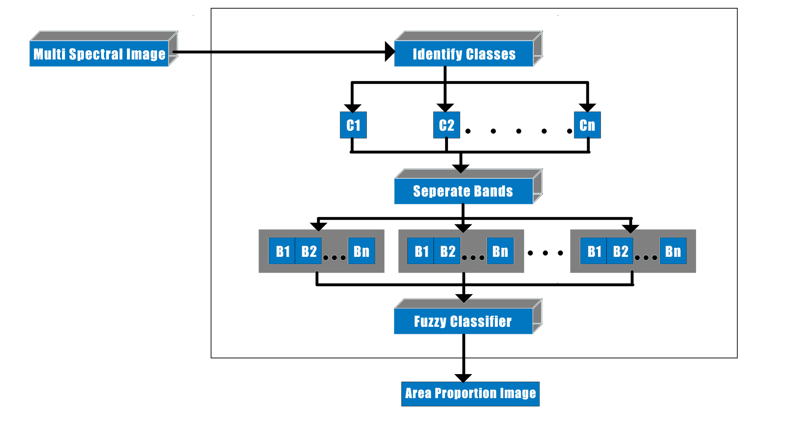

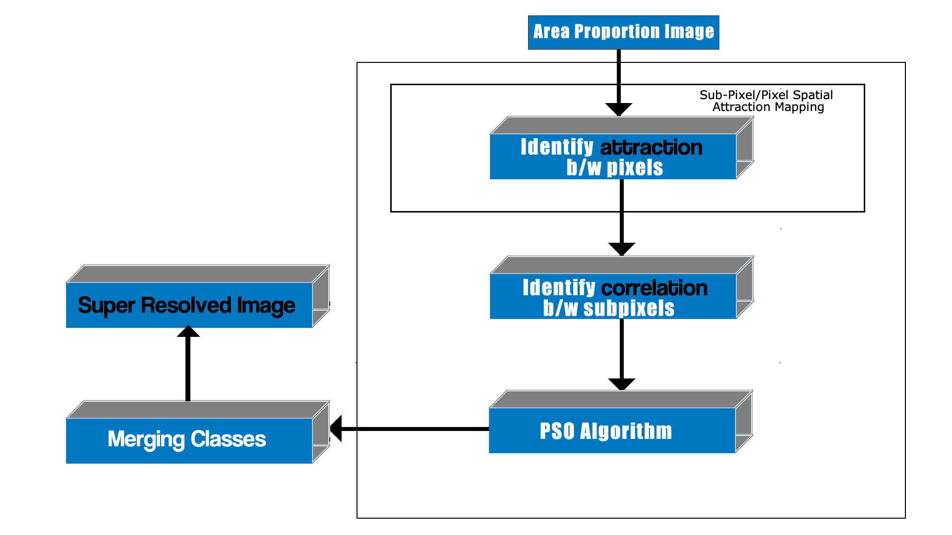

3. Implementation

There are two steps for an Super Resolution Mapping Technique. They are,

* + Soft Classification and
  + Sub-Pixel Mapping

3.1 Soft Classification

The Soft Classification technique used here is the Linear Unmixing Model. This algorithm is used via the ENVI tool for generating the Data Sets (i.e. Soft Classified Image). Although this is a part of the SRM process, here in this project we will be concentrating on the Sub-Pixel Mapping part.

3.2 Sub-Pixel Mapping

The SPSAM is initially used and then PSO Algorithm is applied to map the land cover classes accurately to the sub-pixels.

3.2.1 SPSAM

The mathematical model of the SPSAM is demonstrated below. In SPSAM, attractions between each sub-pixel within a coarse resolution pixel and its neighbor pixels are calculated in order to determine the spatial distribution of sub-pixels per class. Assume p*ij* is a sub-pixel in pixel P*ab* and P*k* is one of P*ab*’s neighbors. Then the attraction from class *c* for sub-pixel p*ij* is calculated as

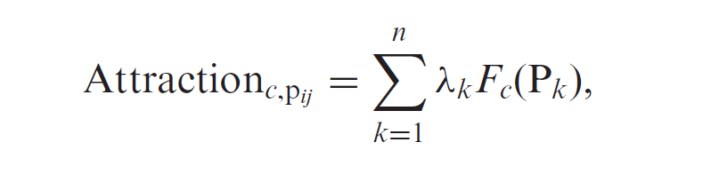

where *n* is the total number of neighbors and *Fc*(P*k*) is the fraction value of the *k*th neighboring pixel P*k* for class *c*. *λk* is the measurement of spatial dependence and is calculated as

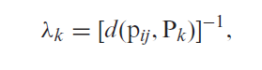

where *d*(p*ij*, P*k*) is the Euclidean distance between geometric centers of sub-pixel p*ij* and its neighboring pixel P*k* and is calculated as

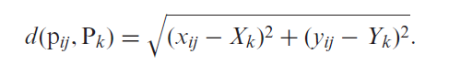

Finally, Attraction*c*,p*ij* for each class can be used for the assignment of sub-pixels to the different classes: sub-pixels with highest attractions are assigned first.

3.2.2 Particle Swarm Optimization

Then, suppose the SPM result SuperA is acquired by the SPSAM procedure and PSO is implemented after it, with the whole process executed as follows.

**Stage 1**: A mixed pixel P*ab* in a coarse low-resolution image (i.e. fraction image) is selected in order and the following six steps of processing are carried out.

Step 1. A swarm with *M* particles is formed with the dimension number *S*2 for each particle *i*, *i* = 1, 2, *. . .* , *M*. Necessarily, the total number (defined as *Ni*) of sub-pixels that belong to class 1 must be *F*(P*ab*)*S*2. For a mixed pixel P*ab*, a certain particle can be extracted from SuperA, the position of which corresponds to the spatial distribution

of the classes in P*ab* itself.

Step 2. The initialization of the velocity for every particle: ***V****i* = [*Vi*1, *Vi*2, *. . .* , *Vim*], *i* = 1, 2, *. . .* , *M*, where the *p*th dimension of the *i*th particle is initialized as

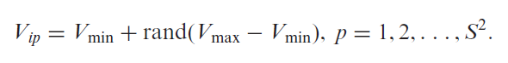

We can set *V*min = –*V*max and then *Vip* is restricted to the interval [–*V*max, *V*max].

Step 3. According to equation (6), the fitness *JXi* of each particle is calculated. Afterwards, the particle ***G***(*t*) that has the highest fitness is selected and it is just the best position in the whole swarm at the *t*th generation. Besides, the best position ***Pi***(*t*) for particle *i* from the first to the *t*th generation is also selected in the same way. The position and velocity are updated, after which the velocity is restricted as

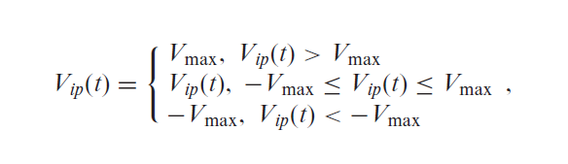

which can prevent the particles from falling into local optima and flying over the best position.

Step 4. The constraint in equation (6) is realized. After one update, *Ni* may not be *F*(P*ab*)*S*2 and measures should be taken to maintain the constraint, which can be realized as follows: if *Ni* is bigger than *F*(P)*S*2, *N*1 – *F*(P*ab*)*S*2 particles that belong to class ‘1’ are randomly selected and changed into ‘0’ while, on the contrary, the selected ones are change into ‘1’.

Step 5. Swarm goes through *R* times evolution according to steps 3 and 4.

Step 6. The best position *X*best during all generations is found out and used to re-decide the spatial distribution of the classes within P*ab* in SuperA.

**Stage 2**: For all mixed pixels in the fraction image, stage 1 is processed.

**Stage 3**: The behavior of the swarm is affected by sub-pixels that are part of neighboring coarse resolution pixels (i.e. p*kn*) and changes in one coarse resolution pixel should have an influence on neighboring coarse resolution pixels. Therefore, stages 1 and 2 are repeated *Q* times, and the SPM result SuperB based on PSO is approached iteratively.

4. Results and Evaluation

The following are the results got from the project after implementing SPSAM along with PSO.

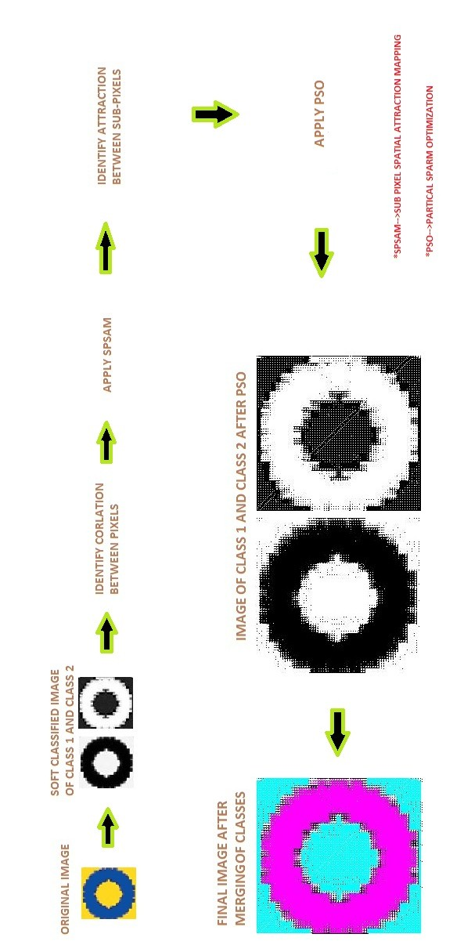

5. Conclusion

The project is completed as per schedule till date and will be completed successfully in time. Till now about 70% of the project has been completed.

7. References

* A. J. Tatem, H. G. Lewis, P. M. Atkinson, and M. S. Nixon, “Super-resolution land cover pattern prediction using a Hopfield neural network,” Remote Sens. Environ. , vol. 79, no. 1, pp. 1–14, Jan. 2002.
* Feng Ling, Yun Du, Fei Xiao, and Xiaodong Li“Subpixel Land Cover Mapping by Integrating Spectral and Spatial Information of Remotely Sensed Imagery” IEEE GEOSCIENCE AND REMOTE SENSING LETTERS., 2011 IEEE.
* P. M. Atkinson, “Issues of uncertainty in super-resolution m apping and their implications for the design of an inter-comparison study,” Int. J.Remote Sens., vol. 30, no. 20, pp. 5293–5308, Oct. 2009.
* A. J. Tatem, H. G. Lewis, P. M. Atkinson, and M. S. Nixon, “Super-resolution target identification from r emotely sensed images using a Hop-field neural network,” IEEE Trans. Geosci. Remote Sens. , vol. 39, no. 4, pp. 781–796, Apr. 2001.
* <http://en.wikipedia.org/wiki/Particle_swarm_optimization>